Step 1: Go to this website: <https://portal.gdc.cancer.gov/exploration>

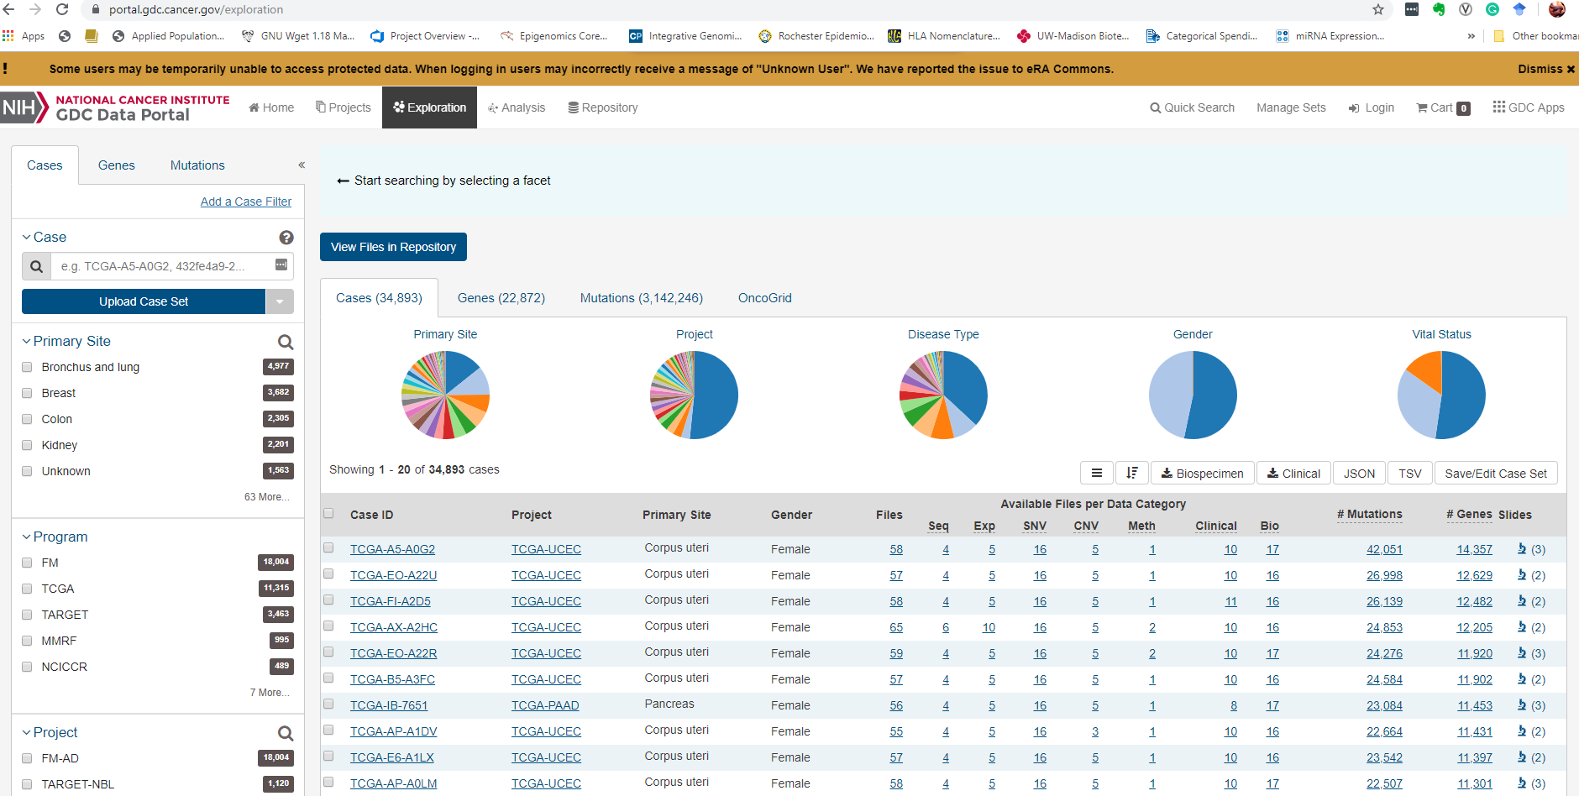

Step 2: Click “Genes”

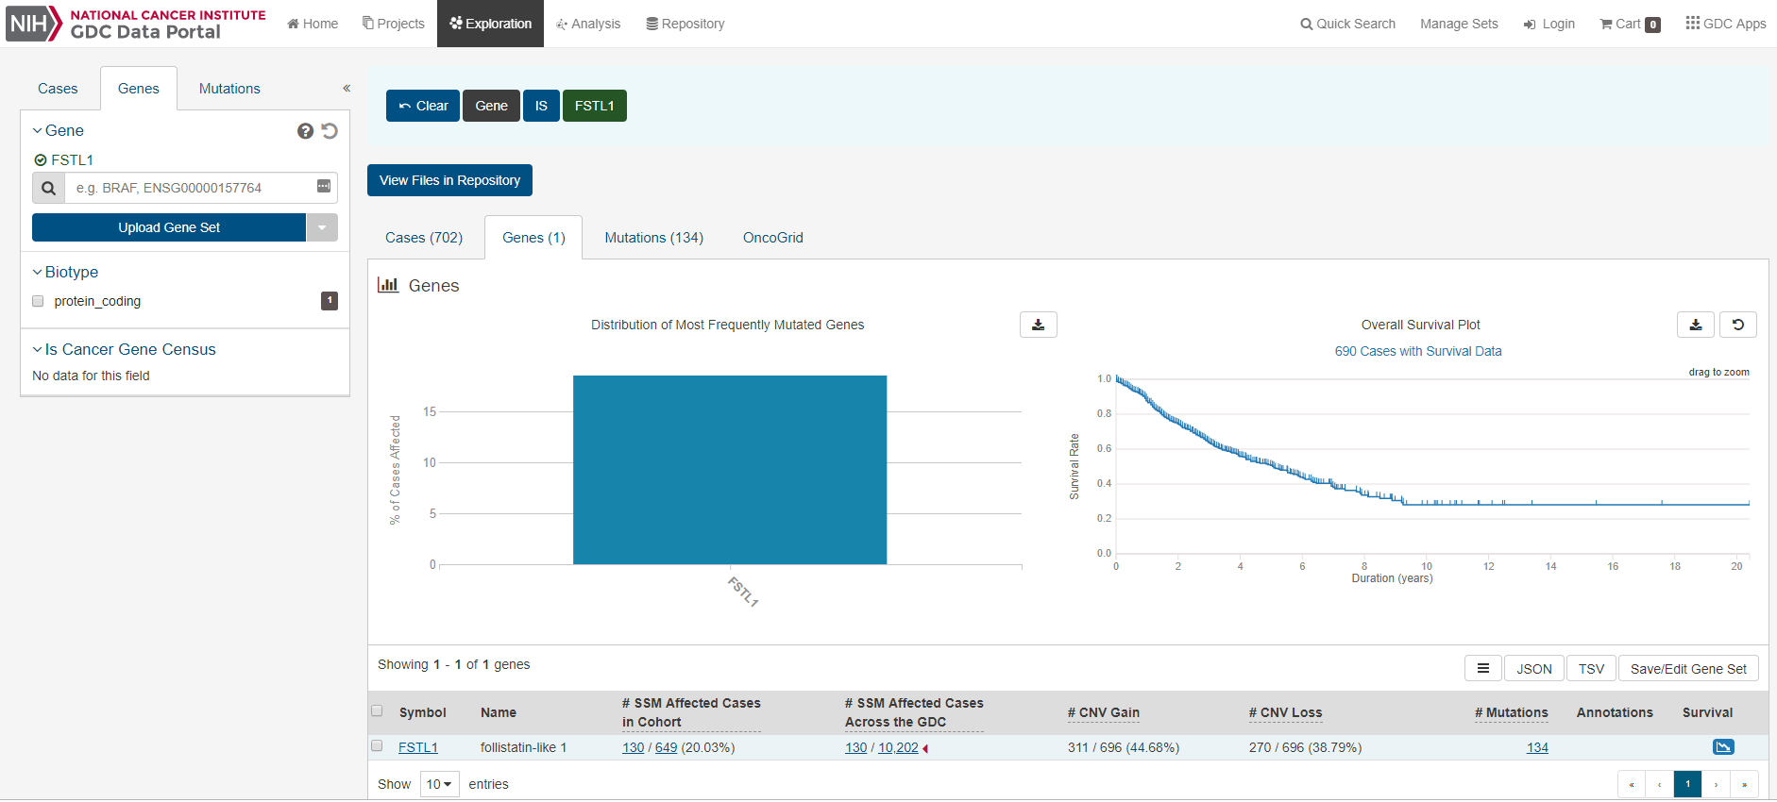

Step 3: Click “Genes” and input Gene Symbol, for example: FSTL1 and then you will find 130 individuals in 10202 overall samples are mutated while others are non-mutated. Click the 130, you will obtain the ID for these 130 individuals.